Treatments:  Topical treatments:  Topical treatments are treatments that are applied directly to the skin, alongside the Supplefeet 10 10 10 method. There are various ointments available with varying amounts of success. They are worth trying in the early stages of a verruca. This method of treatment is ideal for children, where a simple and gentle treatment is required.  Chemical treatments:  Chemical treatments for verrucae include silver nitrate, salicyclic acid, or other compounds. These work by breaking cell linkages and disrupting the viral cell function.  However, perseverance is essential as it may take a few treatments for the chemicals to work. Even if the verruca does not go completely, the chemical treatment and professional debridement can cause a reduction in size; making it feel more comfortable.  N.B. When you have a verruca, there is no need to miss out on swimming. We recommend leaving them alone or painting them with nail varnish to seal it in. |  | How are they applied to the verrucae?  At-home care:  Firstly, wash your feet with hot, soapy water before treatment application and gently rub the hard skin with a foot file or emery board. Then, apply the verruca treatment, i.e. Duofilm and cover with a waterproof plaster.  N.B. Duofilm should be used no more than three times a week on the affected area unless otherwise directed.  In clinic:  If you have a more stubborn verruca, stronger preparations of treatment may be needed. These need to be applied by a podiatrist. These chemicals are strong and could damage the surrounding healthy skin. The chemical treatments can be neutralised by soaking the skin in warm salt water. If the chemicals cause irritation to the healthy skin, treatments need to be stopped until any discomfort subsides. Verrucae are viral; therefore, it is never certain how long treatments will take to work. Usually, results can be seen after four-to-six treatments; however, this varies between patients. | I trust that the information here has been of use to you. We welcome your feedback and me and my team would be happy to answer any queries on 020 8367 9292. Thank you.  Miss Emma Supple  Clinical Director of Supplefeet | Revised February 2021 | - Verrucae - Information for Patients  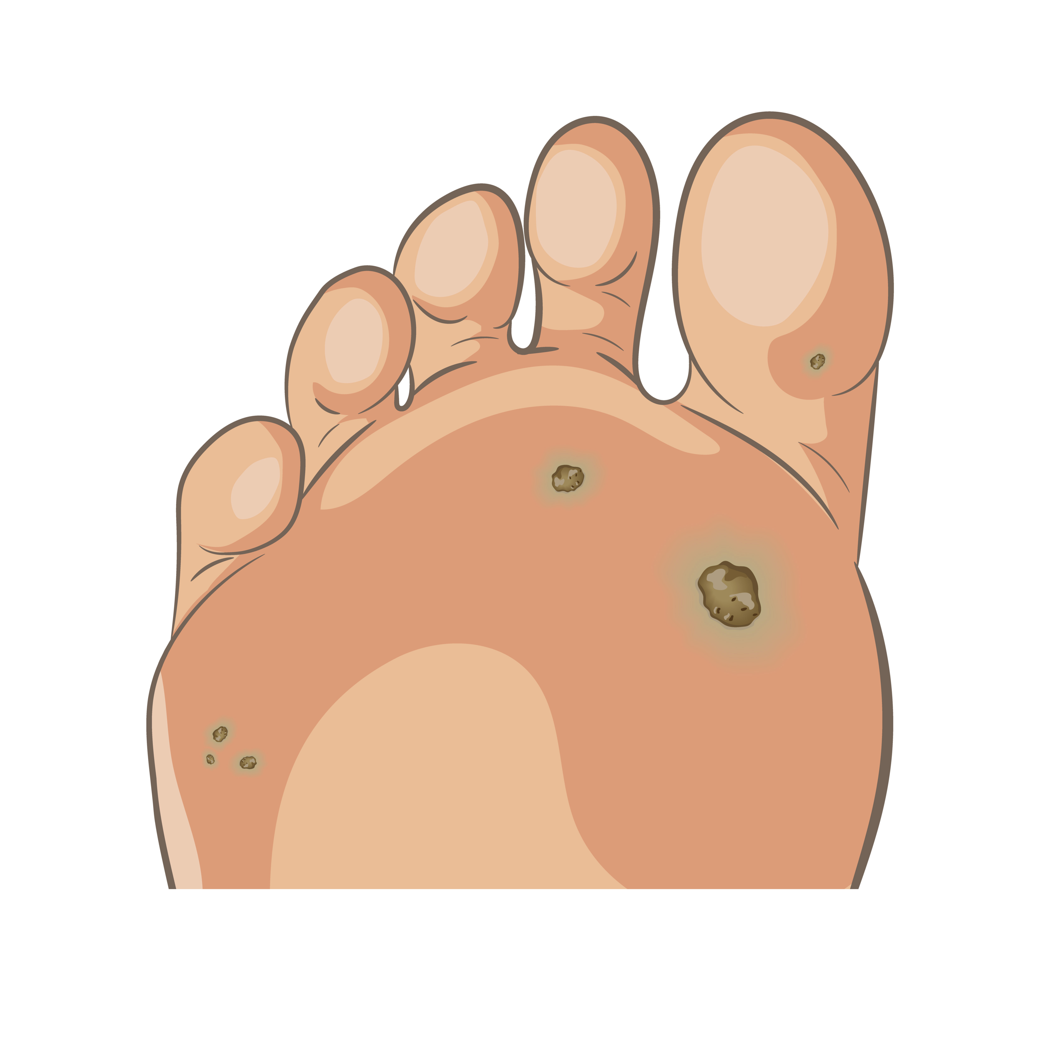  Please contact us for more information using our website www.supplefeet.com or phone us on  020 8367 9292

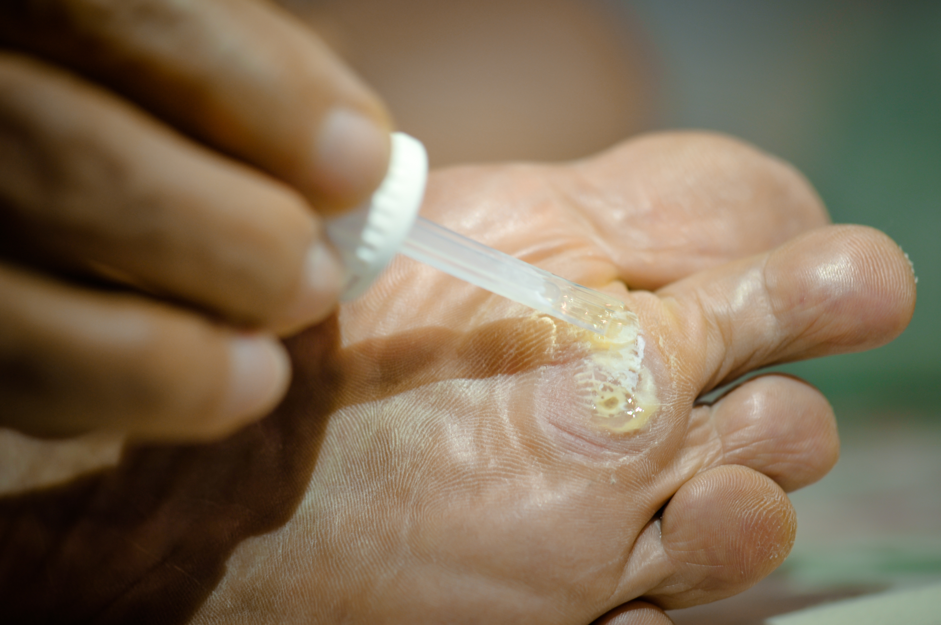  What is a verruca?  Verrucae on feet are simply plantar warts pushed into the skin, think of them as inverted icebergs. They are a very common skin infection that is caused by the human papilloma virus (HPV), that sit below the epidermis. It does not matter how long they have been on your feet; they will never go deeper than the second layer of the skin. They do not appear on the tops of feet, just on the soles and sometimes between the toes because of the plantar skin. They either appear as single lesions or multiple, which are known as mosaic verrucae.  Who gets them?  Verrucae are an opportunistic infection and they can occur at any age. However, children of school age are more likely to have them than adults. If you have a break in your skin, they can be spread between people, or from a contaminated surface, especially communal changing rooms and swimming pools. If you have a weakened immune system, which can be caused by cancer treatment, medications, or even stress, you could be more prone to verrucae. Not everyone develops them though, even when they have been in contact with shared environments. | How do I know if I have a verruca?  - Verrucae tend to have an appearance that resembles cauliflower. They can have black dots, which are the disrupted blood vessels being brought up to the surface.  - They vary in size and number.  - Verrucae are more painful when they are squeezed as opposed to when they are pushed directly.  - They are different from corns and callus.  How are verrucae treated?  With or without treatment, verrucae generally disappear within 18-24 months after infection. It is important not to make the cure worse than the problem. So do not treat unless painful! They do always go-eventually!  There is not a definitive treatment for verrucae. The available treatments aim to destroy the virus and bring about the removal of the verrucae by kickstarting the immune response. At Supplefeet we advise and administer only gentle, non-invasive treatments. We also have had encouraging results from daily supplements of Vitamin A, Zinc and Selenium, which act to boost your immune system and fight the virus from within.  Supplefeet Duofilm  For the treatment of Verrucae  Active ingredients: Lactic Acid and Salicyclic Acid  This product can work very well for children’s verrucae  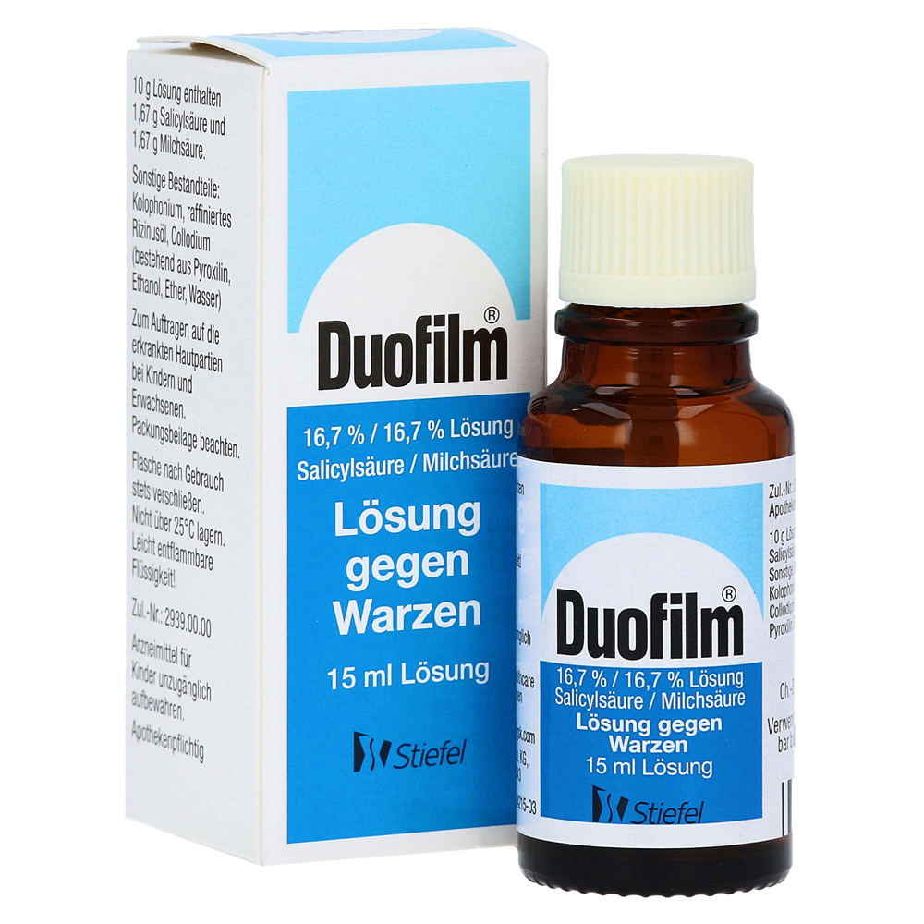 | What to expect at Supplefeet?  In your appointment at Supplefeet, we will diagnose, assess and advise you on your verrucae before carrying out any treatment.  The Supplefeet STOP clause is very important for children or those with a low pain threshold as we use cold spray to help when we are debriding. If you say STOP we stop!  The management of verrucae at Supplefeet involves gentle debridement and the application of low concentration acid treatment. We recommend Duofilm as it contains two acids, lactic and salicyclic acid, which work well in combination.  The alternative is silver nitrate, which turns the area black and forms an oxidative shield. After applying Duofilm or silver nitrate, protective padding should be applied, and the area should be kept clean and dry. Once this comes off, bathing rights are restored. A simple dressing can be supplied for in-between treatments, but a dressing is not necessary.  We debride the verruca using a scalpel blade. We use the special Supplefeet method of 10 10 10 and STOP, a unique to Supplefeet method which gently helps to eradicate the verruca by creating scarification. This gently gets rid of the verruca by helping it to open out. Please note, debriding often causes bleeding, which sounds alarming but is actually good as it stirs up the immune response. They bleed because the virus disrupts the normal skin anatomy, which is seen as the skin striae are pushed out around the lesion, unlike a callus where the skin lines run straight through.

